SESSION 3

INTRODUCTION TO WORKING WITH R  
Assignment – 1

1. How to Import SAS XPORT files into R with the foreign package?

Ans:

SAS XPORT files can be imported to R with “foreign package” using read. xport() function.

Eg:

> library(foreign)

> data<- read.xport("<Path to the file")

2. How to Import SAS Files into R with the Haven package?

Ans :

Similar to foreign package the Haven package allows us to import sas7bdat file to R using the function read_sas()

Eg:

> library(haven)

> read_sas("<Path to the file>")

3. How to read Weka Attribute-Relation File Format (ARFF) files in R? .

Ans:

Data from Weka Attribute-Relation File Format (ARFF) files can be read in with the read.arff() function in foreign package

> library(foreign)

> data <- read.arff("<Path to your file>")

4. How to read a heavy csv/tsv file using readr package?

Ans: he readr package works faster than the read.table function. The end result might be same, but the readr package performs faster than the latter. A large csv/tsv file can be read using read_csv() or read_tsv() function.

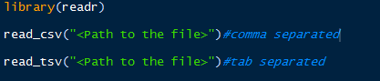Eg: